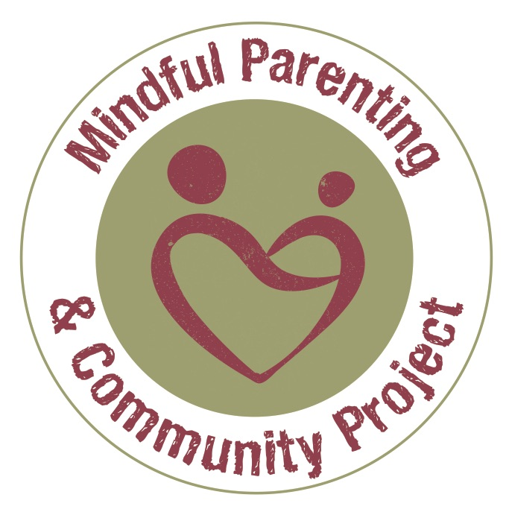

Adopting Mindfulness
8 Week Course
January – March 2018

‘The course marked a shift in how I feel about myself..I’m less hard on myself now..’

‘I have more self awareness of my concerns. (It has) .enabled me to cope with challenging behaviour ..and to respond in an appropriate way & explain why I hold my ground ..I am able to step out of escalating situations to pause, act in amore helpful way

Adoptive parents who attended the Adopting Mindfulness 2017

Taster session: Tuesday 5th December 6.30 – 8pm
The course is a large commitment. The Taster will help you decide whether it is right for you and enable you to meet other adoptive parents interested in mindfulness.

Course time:
6.30 pm - 8.30 pm

Course Dates:
Session 1. January 23rd
Session 2. January 30th
Session 3. February 6th
Session 4. February 20th
Session 5. February 27th
Session 6. March 6th
Session 7.March 13th
Session 8. March 20th

Venue
The Centre, Clifton Children’s Society, Pennywell Road, Bristol BS5 0TX.

Who can apply
The course is for adoptive parents in the Adoption West Consortium with children in placement (pre and post adoption order).

Cost / Funding
Clifton Children’s Society will seek to arrange a block application to the Adoption Support Fund for those attending this course. Adoptive parents considering the course are advised to discuss their interest with their own adoption service in order for the necessary liaison with Clifton Children’s Society to take place.

Why would adoptive parents attend such a course?
Mindfulness is ultimately about keeping physically and mentally well. For parents living with adopted children in the wider context of under-resourced services, life is demanding and, at times, highly stressful. Anxiety depression and a sense of there being no time for self care are common experiences with serious implications for relationships at home and at work. The focus of this course is wellbeing and learning skills that can enhance resilience and emotional regulation: to bring about a shift of aspiration - from surviving to thriving.

The course is, therefore, suitable for adoptive parents interested in learning new ways to improve their wellbeing and to deal with anxiety and low mood. Mindfulness is not always appropriate or helpful, however. Life events or mental health issues may suggest that you seek other forms of support or pursue a mindfulness course at a later date. The pre-course telephone call will help us decide whether this is right for you at this time.

What is mindfulness?

- Mindfulness is a form of meditative practice that helps develop greater clarity of the mind. Mindfulness can help us notice when we are getting caught up in unhelpful mind habits that no longer serve us well. Examples include overthinking, getting entangled in the past, pushing ourselves to meet unreachable standards and prioritising others needs over our own.

- Through mindfulness we can train ourselves to pay full attention to our present moment experience in a way that is both accepting and allowing. This enhanced state of awareness enables us to pause and use our full creative potential to make wise choices on how best to live our lives.

- The practice of mindfulness involves gently turning towards the difficulties and challenges of life. We learn new ways of responding to stress and low mood and create opportunities to live healthier, wiser and ultimately more fulfilling and effective lives.

What are the benefits of mindfulness?

The benefits of Mindfulness are well documented and expanding. Scientific clinical studies show that an 8-week course can:

- Support resilience in the face of anxiety, worry and low mood. Neuro-science is showing how a mindfulness practice offers enhanced protection against depression and symptoms of burn out, improving sleep quality and energy levels.

- Strengthen positive emotions such as happiness, empathy and compassion.

- Develop general self-care and improved management of long-term health conditions.

- Improve relationships with others through taking a calmer and less reactive approach to life.

- Improve concentration and performance allowing you to be more effective in what you do.

Who is the course suitable for?

The course is suitable for adoptive parents interested in learning new ways to improve their wellbeing and deal with anxiety and low mood. Mindfulness is not always appropriate or helpful however. Life events or mental health issues may suggest that you seek other forms of support or pursue a mindfulness course at a later date. The pre-course telephone call will help us decide whether this is right for you at this time.

What does the 8-week course involve?
The course is practical and experiential. It includes:
- 8 sessions of 2 hours
- Guided instruction in various mindfulness practices (taught in an entirely secular way) as developed by medical scientist Jon Kabat Zinn of the University School of Massachusetts Medical School.
- Gentle stretching and mindful yoga.
- Inquiry exercises to enhance awareness in everyday life.
- Discussion in pairs and small groups as well as in the larger group.
- Daily home assignments.
- Audio CDs or an App on your phone and a workbook.

The course is challenging and life affirming. The teacher is skilled in creating a safe supportive and deeply engaging learning environment.

Applying

Step 1: Attend a Taster Session
Contact us to attend the Taster Session so that you can find out more about the course, meet other prospective course members and do a little mindfulness practice. This will help you decide whether it is something that you wish to do. Whilst it is obviously important to attend however, if you cannot make the date, this is not a barrier to attending the course.

Step 2: Complete booking form
The application form will be emailed to you, at your request, following the Taster Session. It seeks basic information and some details to help the teacher discuss the suitability of the course for you at the current time

Step 3: Pre course telephone discussion
When we have your booking form, we will arrange a telephone call to discuss whether the course is appropriate for you at this time.

Course teacher
Jacky Slade has completed the postgraduate Diploma to teach Mindfulness Based Stress Reduction and Mindfulness Based Cognitive Therapy at Exeter University and adheres to the UK Network’s ‘Good Practice Guidelines for Teachers of Mindfulness’. She is a member of the Mindful Parenting Community (Bristol) Project and committed to supporting the development of mindfulness in adoption and fostering services. Her contact details for all questions and booking enquiries are:
Email: mpcp.bristol@gmail.com
Mobile: 0780 300 4785

